EXPLORING MENTAL HEALTH STIGMA AND SUPPORT FOR VETERANS: AN INTERPRETATIVE PHENOMENOLOGICAL ANALYSIS

Example from Best Dissertation Writers

**Table of Contents**

Abstract 3

Introduction 4

Research Questions 4

Research Objectives 5

Literature Review 5

Methods 7

Research Design 7

Data Collection Procedures 7

Data Analysis 7

Limitations 8

Findings 9

Discussion and Conclusion 12

References 16

Appendices 20

Appendix A: Hierarchy Diagram 20

Appendix B: PTSD transcription explore diagram 21

Appendix C: Project Hierarchy Chart 23

Appendix D: Transcript codebook 24

# **Abstract**

This study examines the subjective assessment of mental health, emotions, and thoughts by military veterans and civilians. This study is grounded in qualitative research methods to gain insight into the subjective perspectives and personal encounters of individuals with traumatic conditions, such as Post-Traumatic Stress Disorder (PTSD) and depression. The exploration offers insights into the cultural phenomenon of stigmatisation surrounding mental health, which is evident in the society being studied. This is depicted through the portrayal of a lack of trust and unpredictable behaviour. Access remains a persistent issue that necessitates educational programmes including patients and their families. The discussion focuses on the significance of harmonious living environments, diminished social stigmas, and the development of well-informed assistance for addressing mental health challenges.

Furthermore, the study emphasises the negative repercussions of mental illness, including its impact on interpersonal relationships and daily functioning. Attendees expressed challenges in maintaining strong connections with their family, friends, and colleagues due to misunderstandings or a lack of support. The book extensively covered coping skills and provided detailed explanations of the many methods individuals employed to address their mental health issues. Seeking assistance from healthcare specialists is now less arduous, since individuals can also engage in self-care activities such as physical exercise, meditation, and several other expressive outlets. The study's findings contribute to the existing understanding of individuals with mental diseases, offering valuable insights that can influence healthcare professionals and policymakers.

**Keywords:** mental health, stigma, access restrictions

# **Introduction**

The prevalence of mental disorders, specifically PTSD and depression, among both military veterans and civilians in society is a significant existential dilemma. Although significant efforts have been made to increase awareness, there is still a pervasive lack of understanding and negative attitudes towards mental health. This perpetuates misconceptions and prevents individuals in need from accessing the support and resources they require (Murphy & Busuttil, 2019). The enduring bias highlights the importance of delving more into the reasoning, thinking, and actual experiences of persons dealing with the described issues. Furthermore, the effectiveness of such an endeavour heavily depends on executing a meticulous procedure that includes implementing extensive measures designed to address the diverse requirements of impacted individuals (Bennett et al., 2011). In order to examine the correlation between mental health issues in military veterans and civilians, it is important to explore the accessibility and efficacy of support services in this context, as well as address any obstacles related to language difficulties in mental health communication.

## **Research Questions**

* What factors influence the perceptions of veterans and civilians regarding mental health conditions such as PTSD and depression?
* What are the principal obstacles impeding the provision of mental health support to veterans and their families, and what strategies can be employed to eliminate these barriers?
* What impact can communication breakdowns have on individuals grappling with mental health issues, and what strategies can be implemented to promote understanding and eliminate the social stigma associated with such matters?

## **Research Objectives**

* To investigate the perspectives of civilians and military veterans regarding mental health conditions such as PTSD and depression, as well as the determinants that influence these perspectives.
* Assess the effectiveness and availability of mental health support services for veterans and their families, examining potential remedies and barriers to entry.
* Analyse the challenges associated with conveying information regarding mental health concerns to both the broader public and the communities directly affected by them and propose approaches to improve dialogue and reduce social stigma.

# **Literature Review**

Veterans frequently face complex difficulties that originate from both their personal and public domains (Butler et al., 2011). Bovin et al. (2019) outline the challenges that veterans face when participating in mental health therapy within the Veterans Affairs (VA) system. The primary hurdles encountered by veterans encompass the pervasive societal stigma around mental health, logistical barriers, and uncertainty over the effectiveness of treatment. Furthermore, Taylor et al. (2020) highlights the importance of addressing veterans' understanding of mental health as they transition from military service. The shortage of resources is responsible for the delay in delivering healthcare services to combatants. Given that the transition exacerbates the mental health issues experienced by veterans after their military duty, it is imperative to provide professional support services. Murphy and Busuttil (2019) assert that it is crucial to address the unique mental health requirements of militants in need of assistance. Combat experience, deployment-related stress, and social isolation are potential factors that can contribute to the onset and exacerbation of mental health disorders among veterans. Therefore, by pinpointing the origins of stress, it becomes possible to develop treatments that are specifically tailored to meet the needs of the veterans.

Despite continuous efforts to enhance mental health care for veterans, certain crucial aspects are still being overlooked. Bovin et al. (2019) argue that the primary emphasis should be on enhancing the accessibility and desirability of mental health interventions in the VA, in order to overcome obstacles to seeking assistance. It is crucial to carefully assess the implementation of focused interventions that especially address the anxiety experienced by veterans. These interventions should encompass the dissemination of information to individuals regarding the available resources and the mitigation of the pervasive social disapproval associated with mental health issues. This strategy has the potential to significantly enhance their emotional well-being (Bergen & Labonté, 2020). Continuous research and campaigning are essential to ensure that veterans receive comprehensive assistance necessary for their smooth transition into civilian life.

It is crucial to prioritise the improvement of mental health care for veterans, as well as changing the perspectives of civilians. The studies conducted by Misca et al. (2023) and Okkels et al. (2018) highlight the importance of customised care and targeted interventions for addressing the unique mental health challenges faced by veterans and civilians in different cities. These studies emphasise the importance of addressing stereotypes and stressors in order to enhance the efficacy of treatment and ensure equitable mental health outcomes.

Mental illness prevents people from seeking treatment and affects clinical care. Corrigan and Watson (2002) examined how stigma affects mental health patients' relationships, self-esteem, and therapy. Understanding the causes and effects of this bias is essential to launching anti-stigma campaigns and building a supportive community for mental health patients (Campbell et al., 2021; Cheney et al., 2018). Clarifying mental illness misconceptions can inspire solidarity and compassion, inspiring people to prioritise their own well-being.

# **Methods**

## **Research Design**

This qualitative study applied IPA (Interpretative Phenomenological Analysis) method to investigate into a part of lived experiences of people with mental health issues such as military veterans and civilians. IPA was utilized because it has the ability to explore participants' personal experiences and their meaning-making in depth (Howitt, 2019; Bergen & Labonté, 2020). Interviewees were encouraged to share their perspectives, opinions, and challenges on mental health during semi-structured interviews. These interviews generated data that was contextualized and diverse.

## **Data Collection Procedures**

This analysis used the interview transcripts that were extracted from the recorded interviews of participants from both veteran and civilian population. Participants were selected through purposive sampling, aiming to cover a broad range of experiences and views related to mental health. Semi-structured interviews took place in the private rooms where participants felt comfortable and confident to reveal their feelings and stories.

## **Data Analysis**

The interview transcripts were analyzed by using NVivo software with a coding and the thematic analysis tailored for the specific research aim. The objective of the first part which centers on the mental health perceptions and attitudes among the military veterans and civilians will be addressed through the identification of the recurring patterns and themes related to them by line-by-line coding. Through the process, primary themes that included stigma, awareness, and coping mechanisms among others, emerged which were a reflection of the diverse views of the two populations. These themes were further developed and situationalized to clearly communicate the intricacies that distinguish veterans` and civilians` mental health approaches.

The second objective looked at the accessibility and usefulness of mental health support services and the analysis into the participants’ experiences about getting and using such resources was also undertaken. The barriers to access, satisfaction with services and perceived effectiveness are among the themes that are directly from the research data. Through systematic coding and categorization of participants' responses, analysis demonstrated that both veterans and general population face major barriers to accessing appropriate support and the factors behind their opinions on the efficiency of the services. Furthermore, the study looked into the differences in experiences in regard to parameters like geographical location, social status, and preceding usage of mental health services.

The analysis looked at communication issues and strategies in mental health discourse as well. The themes of communication barriers, stigma reduction strategies, and effective communication channels were picked out through the process of iterative coding and constant comparison. Participants' experience and perception of communication within social networks, health care settings, and broader societal contexts were studied for ways for improvement are recommended. Through examining mental health communication in detail, the study revealed the ways to improve mental health literacy and create beneficial environments for individuals suffering from mental illnesses.

## **Limitations**

One limitation of this study is the potential for subjectivity and participant bias, as individuals may interpret their mental health experiences differently (Hartmann et al., 2018; Roulston, 2010). Additionally, the sample size and demographic diversity of participants may affect the generalizability of the findings to the broader population. Moreover, relying on self-reported data and retrospective narratives could introduce recall bias and limit the accuracy of experiences portrayed (Roulston, 2010). However, stringent data collection and analysis methodologies were employed to mitigate bias and ensure the validity and reliability of the study's findings (Shaw et al., 2019).

# **Findings**

The examination of the transcripts, as revealed by Harrison and Hillary, as well as Chris and Willie, provides insights into their perspectives on mental health, particularly with PTSD and depression. Both veterans and civilians hold diverse perspectives that are shaped by the culture they reside in and their personal experiences.

Discussing mental health provides an opportunity for veterans to express their frustrations with societal attitudes. Although individuals may fail to perceive the underlying issues and hence lack comprehension and willingness to acknowledge them, this statement encapsulates the various societal prejudices around mental disorders, which contribute to the patient's sense of isolation and bewilderment. Furthermore, his assertion that discrimination or trivialization of mental health concerns demonstrates the need for increased education and awareness to confront stereotypes.

The findings further emphasise the significance of cultural factors in influencing individuals' perspectives on mental health. The societal conflict experienced by Harrison reflects the larger difficulty of eradicating misunderstandings and promoting acceptance. Moreover, the conversation between Chris and Willie underscores the contrasting viewpoints held by military members and civilians, underscoring the importance of culturally attuned mental health services. Given the impact of culture on attitudes and behaviours, it is crucial for treatments to prioritise cultural understanding in order to promote a feeling of belonging and respect among persons seeking support.

Furthermore, Willie, in his civilian role, aids in our comprehension of the challenges associated with managing communication and interpreting meanings. Willie observes the stark contrast between the experiences of veterans and civilians, noting that many civilians with mental health concerns often anticipate receiving emotional support and comforting conversations. He is illustrating a disparity between the actualities and anticipations of mental health assistance. This emphasises the importance of employing a range of solutions that include different perspectives and the preferences of individuals requiring help.

Conversely, transcripts provide valuable information regarding the barriers that prevent individuals, particularly veterans and their families, from accessing mental health services. Harrison emphasises the issue of inadequate support for relatives of individuals with mental health issues, questioning, "Who takes on the responsibility or provides assistance for them?" This highlights the imperative of adopting a comprehensive approach that addresses the needs of individuals and their close relations. In addition, populations facing marginalisation and individuals residing in rural locations typically encounter challenges in terms of both finances and logistics when it comes to receiving mental health care.

Moreover, the challenges in communicating pose the most significant obstacle to acquiring knowledge about and reducing the stigma around mental illness. Chris recounts his interactions with the civilians. He additionally asserts that, "They were unable to cope with it...I was an outsider to them," suggesting the want for improved communication tactics that might encompass empathy and comprehension inside a heterogeneous group. It underscores the importance of fostering open communication and overcoming barriers in order to assist individuals experiencing mental health issues.

The paper also reveals the evolving characteristics of mental health disorders, such as the case of persons like Chris who demonstrate dramatic fluctuations between periods of heightened and depressed moods. Chris candidly explains, "The day after, I found myself at a DIY store, meticulously measuring a rope, the kind typically utilised for self-suspension." This underscores the actualities of mental health and the imperative for robust support systems. This method emphasises individualised and ongoing care that considers unique challenges of each patient.

The transcripts disclose the intricate correlation between mental well-being and social support systems. For example, Harrison and Chris have difficulties in their personal connections while managing mental health conditions. The challenges Harrison faces in seeking purpose within his social circle, along with Chris's contemplation on the significance of social bonds, highlight the criticality of nurturing relationships and fostering compassionate communication. Efforts to promote mental health recovery should give priority to the development of supportive networks and the improvement of communication skills. By promoting empathy, practicing active listening, and cultivating mutual respect within communities, individuals can experience validation and empowerment to seek assistance and actively participate in their process of healing.

Essentially, the findings underscore the importance of addressing preconceptions and other obstacles to access, as well as adapting communication methods to promote mental health. This qualitative study, which entails amplifying a range of perspectives and experiences, also contributes to a deeper comprehension of the intricacies associated with PTSD and depression. It provides insights into the real-life experiences of individuals and families affected by these diseases, highlighting the areas that require improvement and interventions to ensure universal access to mental health wellbeing.

# **Discussion and Conclusion**

The narratives provided us with a comprehensive insight into the perspectives of soldiers and civilians on mental health conditions such as PTSD and depression. This finding aligns with previous research that has shown the pervasive nature of the mental health stigma (Corrigan & Watson, 2002). However, the presentations given by Harrison and Chris also highlighted the social aspect that often acts as a barrier, preventing people from openly discussing their problems or seeking advice. In addition, elucidate the challenges faced by veterans and their families in accessing mental healthcare. Initiating the exploration of culturally suitable healthcare highlights the necessity for immediate measures (Okkels et al., 2018; Gatz et al., 2007). In addition, the limited healthcare network, and the issue of funding resources for former servicemen were evident in Chris, who served as an illustration (Hales et al., 2019). These facts serve as excellent illustrations of the significance of addressing stigmas and using culturally competent healthcare delivery approaches.

Similarly, we acknowledge the presence of a communication gap that poses a challenge for many individuals with mental health conditions. The alienation experienced by Harrison and Chris represents an ongoing sense of loneliness that has not been fully eliminated from our societies (Murphy & Busuttil, 2019; Mehta et al., 2015). This information serves as the basis for both empathetic communication and the existence of supporting networks, which create a secure environment where individuals can openly share their experiences. Developing strong bonds and intimacy with friends can facilitate the process of emotional healing. In contrast to Chris, Harrison's harrowing encounter without a structured assistance demonstrated the detrimental impact of lacking such support, as well as its potential for recovery (Misca et al., 2023; Morgan et al., 2018; Pietrzak et al., 2009). The recovery potential of a stroke patient following a brain haemorrhage may be influenced by the presence of supportive family members or friends who can help and emotional support.

The narratives consistently emphasise the importance of mental health care that is adaptable to individuals from all backgrounds and acknowledges the complexity of each person's experiences. By expanding our comprehension of others' perspectives on these matters and considering the IPA standpoint, as proposed by Bovin and others, we acquire profound insights into the unique individual experiences that accompany societal membership. Furthermore, the performance of the system is heavily influenced by a distinctive strategy that considers the specific requirements and comprehensive perspective of individuals. Furthermore, the plotlines emphasised the importance of including de-stigmatization initiatives as a crucial component of the heightened awareness and subsequent acceptance process. The two brothers demonstrated through anecdotes how it is possible to challenge societal norms and emphasised the importance of empathy and comprehension (Corrigan and Watson, 2002; Richards et al., 2016).

Moreover, the narratives emphasised the importance of implementing holistic approaches in mental healthcare that go beyond treating symptoms alone. It is crucial to also consider the economic aspects that influence mental health. The lecture focused on the discussion of social deficiencies and societal stigma, which have the potential to adversely affect individuals' mental health well-being (Taylor et al., 2020; Russell et al., 2016). Research evidence examines the various aspects of patients' living situations, emphasising the significance of a holistic therapy approach that considers the patient's socio-economic status (Stotzer et al., 2012). Aside from the existing disparities related to social gender and ethnicity, implementing comprehensive care (wrap-around services) can significantly boost the efficacy of interventions and facilitate long-term recovery.

Additionally, the diaries effectively convey the concept of interpersonal connections and the interconnectedness of communities as fundamental elements of mental well-being. Harrison and Chris emphasised the importance of veterans, like themselves, in networking. This can be achieved by collaborating with social media groups or independently networking (Bovin et al., 2019; Thornicroft et al., 2016). Therefore, these findings suggest the necessity of creating community environments specifically tailored for the purpose of fostering self-expression, empathy, and maybe interdependence in order to offer support. To do this, we will establish peer support groups and community care resources in order to improve social contacts and reduce isolation among those with mental health conditions.

The narratives in the research demonstrate the importance of addressing preconceptions and other obstacles to access, while emphasising the necessity of adapting communication methods to support mental well-being (Corrigan & Watson, 2002). Harrison and Chris's estrangement serves as a clear example of the profound loneliness experienced by those facing communication barriers, a challenge commonly observed among mental health patients. This rift is also present within our communities, as highlighted by studies conducted by Murphy and Busuttil (2019) and Van Voorhees et al. (2018). One significant theme that arises from the narratives is the necessity of a mental health treatment system that is adaptable to persons from all backgrounds and capable of acknowledging the profoundness of each person's experiences (Bovin et al., 2019).

Ultimately, these narratives offer a profound comprehension of the experiences of individuals who are afflicted. To effectively manage mental health difficulties, it is crucial to tackle stigmatisation, foster supportive social networks, and prioritise person-centred care (Okkels et al., 2018). By understanding these aspects of an individual and recognising the ways in which socio-cultural factors overlap, we may create mental health support systems that are fair and encompassing. Nevertheless, the researcher must consider the constraints of this study, namely a limited sample size and potential bias in participant selection. Subsequent investigations should prioritise augmenting the sample size and include diverse demographic cohorts to authenticate these discoveries. Furthermore, longitudinal studies can offer valuable understanding regarding the enduring effects of mental health treatments and the determinants that affect the sustainability of recovery.

# **References**

Bennett, E. A., Crabtree, M., Schaffer, M. E., & Britt, T. W. (2011). Mental health

status and perceived barriers to seeking treatment in rural reserve component

veterans. *Journal of Rural Social Sciences*, *26*(3), 6.

Bergen, N., & Labonté, R. (2020). "Everything Is Perfect, and We Have No Problems":

Detecting and limiting social desirability bias in qualitative research. *Qualitative Health*

*Research*, *30*(5), 783-792. https://doi.org/10.1177/1049732319889354

Bovin, M. J., Miller, C. J., Koenig, C. J., Lipschitz, J. M., Zamora, K. A., Wright, P. B., ... &

Burgess Jr, J. F. (2019). Veterans’ experiences initiating VA-based mental health

care. *Psychological services*, *16*(4), 612-620. https://doi.org/10.1037/ser0000233

Butler, L. D., Critelli, F. M., & Rinfrette, E. S. (2011). Trauma-informed care and mental

health. *Directions in Psychiatry*, *31*(3), 197-212.

Campbell, S. B., Gray, K. E., Hoerster, K. D., Fortney, J. C., & Simpson, T. L. (2021).

Differences in functional and structural social support among female and male veterans and

civilians. *Social psychiatry and psychiatric epidemiology*, *56*, 375-386.

https://doi.org/10.1007/s00127-020-01862-4

Cheney, A. M., Koenig, C. J., Miller, C. J., Zamora, K., Wright, P., Stanley, R., ... & Pyne, J.

M. (2018). Veteran-centred barriers to VA mental healthcare services use. *BMC Health*

*Services Research*, *18*(1). https://doi.org/10.1186/s12913-018-3346-9

Corrigan, P. W., & Watson, A. C. (2002). Understanding the impact of stigma on people with

mental illness. *World Psychiatry: Official Journal of the World Psychiatric Association*

*(WPA)*, *1*(1), 16-20.

Gatz, M., Brown, V., Hennigan, K., Rechberger, E., O'Keefe, M., Rose, T., & Bjelajac, P.

(2007). Effectiveness of an integrated, trauma‐informed approach to treating women with co‐

occurring disorders and histories of trauma: The Los Angeles site experience. *Journal of*

*Community Psychology*, *35*(7), 863-878. https://doi.org/10.1002/jcop.20186

Hales, T. W., Green, S. A., Bissonette, S., Warden, A., Diebold, J., Koury, S. P., &

Nochajski, T. H. (2019). Trauma-informed care outcome study. *Research on Social Work*

*Practice*, *29*(5), 529-539. https://doi.org/10.1177/1049731518766618

Hartmann, W. E., St. Arnault, D. M., & Gone, J. P. (2018). A Return to "The Clinic" for

Community Psychology: Lessons from a Clinical Ethnography in Urban American Indian

Behavioral Health. *American Journal of Community Psychology*, *61*(1–2), 62–75.

https://doi.org/10.1002/ajcp.12212

Howitt, D. (2019). *Introduction to qualitative research methods in psychology: Putting*

*theory into practice.* Pearson UK.

Mehta, N., Clement, S., Marcus, E., Stona, A. C., Bezborodovs, N., Evans-Lacko, S., ... &

Thornicroft, G. (2015). Evidence for effective interventions to reduce mental health-related

stigma and discrimination in the medium and long term: systematic review. *The British*

*Journal of Psychiatry*, *207*(5), 377-384.

Misca, G., Augustus, J., Russell, J., & Walker, J. (2023). Meaning (s) of transition (s) from

military to civilian life at the intersection with mental health: implications for clinical

settings. *Frontiers in Psychology*, *14*, 1142528.

Morgan, A. J., Reavley, N. J., Ross, A., San Too, L., & Jorm, A. F. (2018). Interventions to

reduce stigma towards people with severe mental illness: Systematic review and meta-

analysis. *Journal of psychiatric research*, *103*, 120-133.

Murphy, D., & Busuttil, W. (2019). Understanding the needs of veterans seeking support for

mental health difficulties. *BMJ Military Health, 166*(4), 211-213.

https://doi.org/10.1136/jramc-2019-001204

Okkels, N., Kristiansen, C. B., Munk-Jørgensen, P., & Sartorius, N. (2018). Urban mental

health: challenges and perspectives. *Current Opinion in Psychiatry*, *31*(3), 258-264.

https://doi.org/10.1097/YCO.0000000000000413

Pietrzak, R. H., Johnson, D. C., Goldstein, M. B., Malley, J. C., & Southwick, S. M. (2009).

Perceived stigma and barriers to mental health care utilization among OEF-OIF

veterans. *Psychiatric services*, *60*(8), 1118-1122. https://doi.org/10.1176/ps.2009.60.8.1118

Richards, L. K., Goetter, E. M., Wojtowicz, M., & Simon, N. M. (2016). Stigma and health

services use among veterans and military personnel. *Stigma and prejudice: Touchstones in*

*understanding diversity in healthcare*, 203-226.

Roulston, K. (2010). Considering Quality in Qualitative Interviewing. *Qualitative*

*Research*, *10*(2), 199–228. https://doi.org/10.1177/1468794109356739

Russell, D. W., Benedek, D. M., Naifeh, J. A., Fullerton, C. S., Benevides, N., Ursano, R. J.,

... & Forsten, R. D. (2016). Social support and mental health outcomes among US Army

Special Operations personnel. *Military Psychology*, *28*(6), 361-375.

Shaw, R. L., Bishop, F. L., Horwood, J., Chilcot, J., & Arden, M. A. (2019). Enhancing the

quality and transparency of qualitative research methods in health psychology. *British*

*Journal of Health Psychology*, *24*(4), 739–745. https://doi.org/10.1111/bjhp.12393

Stotzer, R. L., Whealin, J. M., & Darden, D. (2012). Social work with veterans in rural

communities: Perceptions of stigma as a barrier to accessing mental health care. *Advances in*

*Social Work*, *13*(1), 1-16. https://doi.org/10.18060/1891

Taylor, S., Miller, B. L., Tallapragada, M., & Vogel, M. (2020). Veterans' transition out of

the military and knowledge of mental health disorders. *Journal of Veterans Studies, 6*(1), 85.

<https://doi.org/10.21061/jvs.v6i1.131>

Thornicroft, G., Mehta, N., Clement, S., Evans-Lacko, S., Doherty, M., Rose, D., ... &

Henderson, C. (2016). Evidence for effective interventions to reduce mental-health-related

stigma and discrimination. *The Lancet*, *387*(10023), 1123-1132.

https://doi.org/10.1016/s0140-6736(15)00298-6

Van Voorhees, E. E., Wagner, H. R., Beckham, J. C., Bradford, D. W., Neal, L. C., Penk, W.

E., & Elbogen, E. B. (2018). Effects of social support and resilient coping on violent

behaviour in military veterans. *Psychological Services*, *15*(2), 181-190.

https://doi.org/10.1037/ser0000187

# **Appendices**

## **Appendix A: Hierarchy Diagram**

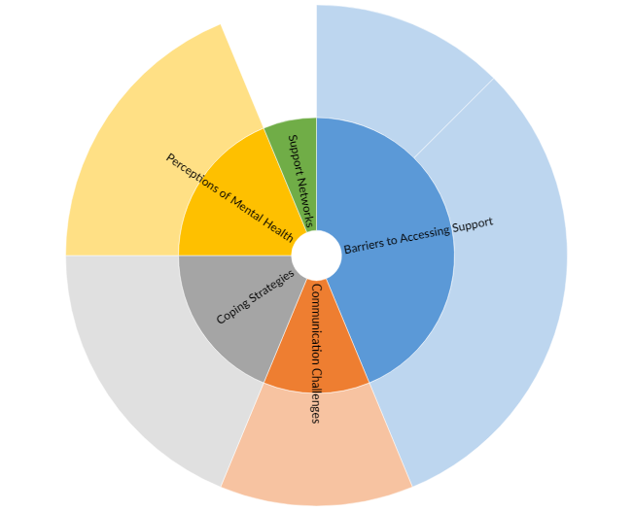

## **Appendix B: PTSD transcription explore diagram**

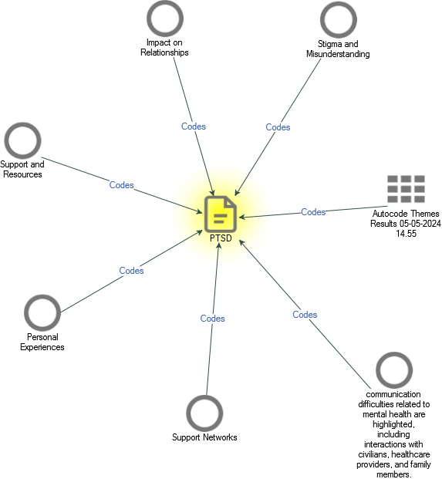

PTSD transcription explore diagram

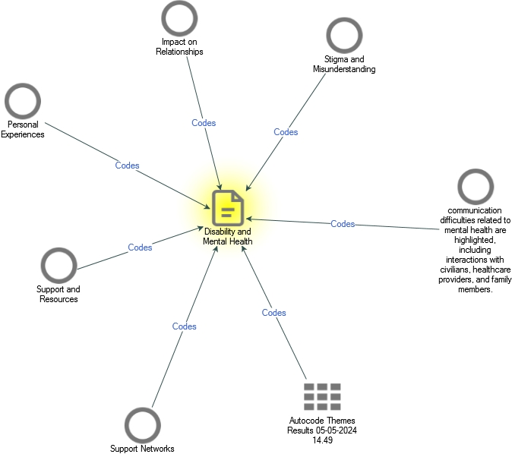

## **Appendix C: Project Hierarchy Chart**

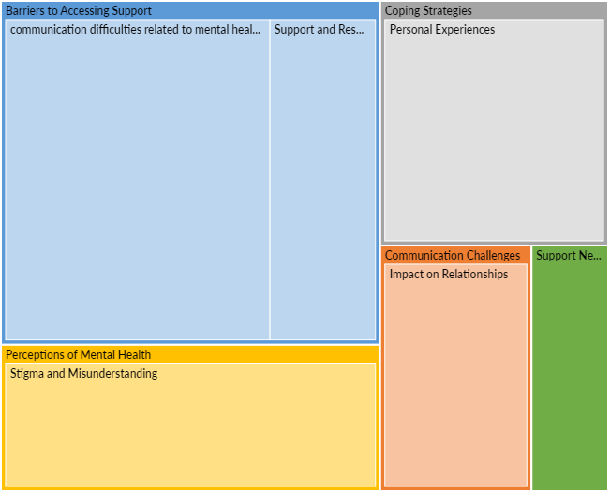

## **Appendix D: Transcript codebook**

